Module 8: Portfolio Project – Option 1

Denise Jovanovich

MIS543 – Enterprise Performance Management

Colorado State University – Global Campus

Dr. Orenthio Goodwin

February 7, 2020

Module 8 – Portfolio Project – Option 1

This portfolio project includes development of business questions, relevant hypotheses and both descriptive and predictive analytics to support a retail clothing store’s goal ofincreasing marketing programs effectiveness.

**Increasing a Retailer’s Marketing Program Effectiveness**

A dataset of 27,799 customers of a retail clothing store will be evaluated to determine how to increase the effectiveness of the company’s marketing promotions. In the dataset, there are several variables relating to customer such as cluster, purchase behavior, sales, and promotions. To help the company reach its goal of increasing marketing program effectiveness, the following set of business questions has been developed, along with related hypothesis statements, that will be analyzes through appropriate statistical techniques.

**Business Questions**

Business questions drive a deeper focus on company strategic outcomes. To assist the company in reaching the goal of improving effectiveness of marketing promotions, the following four business questions have been identified:

* *is there an optimal number of marketing promotions as it relates to sales?*
* *is there an optimal number of marketing promotions as it relates to frequency of visits?*
* *which customer types are most influenced by our promotions?*
* *what is the relationship between profitability and promotions?*

These questions, and the related hypotheses, will be further assessed for approaches to appropriate statistical tests and visualizations. To begin, some initial descriptive statistics are run on the dataset using a proc means statement (see Figure 1). See Appendix A for all SAS code.

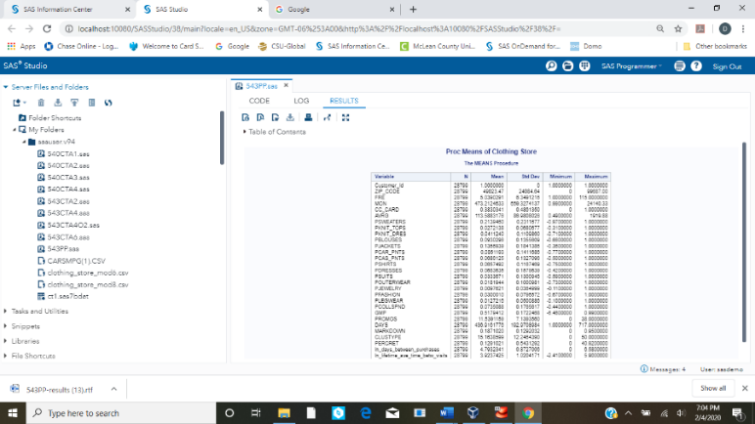

*Figure 1.* Proc Means Results

**Relationship Between Sales and Promotions**

To assist the retailer, a focus on better understanding of sales and visits generated by promotions by addressing the question, and the related hypotheses to test: *is there an optimal number of marketing promotions as it relates to sales?*

*H0: Sales and promotions received are not related*

*H1: Sales and promotions received are related*

As both of these variables are numerical and continuous, the first statistical test to assess this relationship is a correlation. A correlation coefficient is a measure of linear relationship between two variables (Elliot and Woodward, 2016). Several variables were assessed for their relationship with each other with a single PROC CORR statement, with results of this analysis found in Figure 2. From this analysis, sales and promos have a positive correlation of 0.44, which is moderate. However, total sales is strongly correlated to frequency of visits (a positive correlation of 0.71). In further reviewing the correlation analysis, the number of days between purchases and lifetime average days between visits are both negatively correlated with total sales (-0.49 and -0.50 respectively).

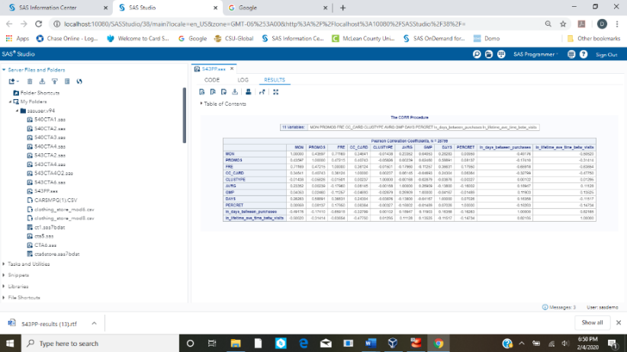

*Figure 2*. Initial Proc Corr Results

The scatterplot (see Figure 3) helps visualize the relationship between total sales and promos (on the left) and between total sales and frequency of visits (on the right).



*Figure 3.* Scatterplot of Correlations Total Sales



*Figure 4.* Bar/Line Chart

Figure 4 includes a bar and line chart showing the total sales and count of customers by the number of promotions received. This chart gives insight to the high counts of customers who receive 5 or 15 promotions (Figure 1 shows the mean promotions as 11.53) and the large volume of total sales from customers receiving 16-22 promotions.

The correlation analysis shows several of these variables are indeed related, and understanding how each contributes to total sales was evaluated through a multiple regression model. This model resulting in the highest R value 0.67 with promotions, frequency of visits, average purchase, gross margin, tenure of the customer in days contributing positively to sales and percent returns, days between purchases, and days between visits contributing negatively to sales.

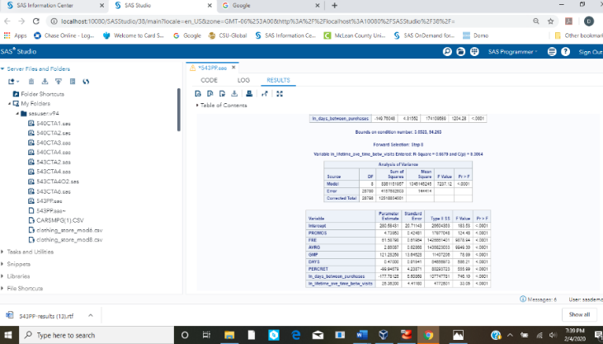

Figure 5. Regression Model for Total Sales

**Relationship Promotions and Frequency of Visits**

Another question of interest would be to understand the relationship between promotions and visits by addressing the question: *is there an optimal number of marketing promotions as it relates to frequency of visits?* The related hypotheses to test for this question are:

*H0: Frequency of Visits and promotions received are not related*

*H1: Frequency of Visits and promotions received are related*

These variables are also numerical and continuous. A correlation analysis between Promos and Frequency, as shown in Figure 2, is 0.42. A scatterplot visualizes this relationship on the left in Figure 6, and the middle bar chart shows the volume of sales by number of promotions and a line for mean frequency of visits by number of promotions. Frequency of visits increases with number of promotions received, but this does not seem to translate into high volume of sales. On the far right, the mean sales and mean frequency of visits increases with promotions received.



*Figure 6.* Scatterplot and Bar/Line chart for Frequency of Visits

**Customer Segments and Promotions**

Because the company is looking to address marketing effectiveness, the customers being targeted is also an important variable to assess. Understanding more about targeted customers and sales outcomes leads to a need to know the answer to the question: *which customer types are most influenced by our promotions?* The related hypotheses to test for this question are

*H0: Customer clusters are equally influenced by promotions*

*H1 Customer clusters are not equally influenced by promotions*

Customer segments is a categorical variable and should be assessed for relationship to promotions with analysis of variance (ANOVA). According to Elliot and Woodward (2016), ANOVA is a combination of analysis of variance and regression, where the group means are adjusted by the covariate (p 327). The PROC ANOVA analysis results indicate there are significant differences in the distribution of promotions across clusters (rejection of the null hypothesis). In reviewing the ANOVA results showing comparisons between each cluster, it is challenging to determine if these differences are practical in significance or just due to the large differences in size of clusters. For instance, most customers are in clusters, 1, 10, 4(visualized in the bar/line chart on the right in Figure 7) and these three clusters have significant differences from clusters 38,17, and 40. On the reverse of this scenario, in looking at the variance, it would appear cluster 19 and 33 would have significant differences, but these are two very small clusters and there was not a statistical difference between these two clusters.



*Figure 7.* ANOVA and Bar/Line Chart for Customer Cluster and Promos Received

In reviewing the promos by customer cluster results, the relationship between sales and customer cluster also reviewed. A bar/line graph (left in Figure 8) promos shows mean sales and mean number of promos by cluster, and where some clusters may generate higher mean sales for the number of promotions received (Clusters 19, 23, 27, 4,10, and 50) while other clusters do not generate the sales for the promotions received (Clusters 9, 33, 44 and 47). These relationships are further visualized in the heatmap on the right in Figure 8. In general, higher mean sales come from higher counts of promos (more red, yellow and bright green at the top part of the heatmap) but this relationship is not even across all clusters.



*Figure 8.* Bar/Line Chart and Heatmap for Mean Sales and Promos by Cluster

**Profitability and Promotions**

Sales are important, and the retailer may also be concerned with profitability, which is an aspect of efficiency in generating sales. The company can focus further by addressing the question: *what is the relationship between profitability and promotions?* Addressing this question may require looking into specific products sold, but the hypotheses below must first be tested.

*H0: Profitability and promotions received are not related*

*H1: Profitability and promotions received are related*

Figure 2 shows the results of correlation between profit and promotions as 0.02 which means there is no relationship between these variables (acceptance of the null hypothesis). This perhaps makes sense as it has long been known that the strongest relationship to profit is market share as it drives economies of scale (Buzzell, Gale, and Sultan, 1975) In the variables included in the initial PROC CORR, there was only a weak relationship between profit and average purchase (0.27). An additional PROC CORR was run to see if any other variables had a relationship to profit with percent on collectibles yielding a weak relationship (0.24) and markdown resulting in a fairly moderate negative relationship (-0.67).

To further understand how certain product sales impact profitability, a regression model that included all variables was run resulting in just a few variables not being significant (Jewelry, Blouses, Knit Tops, Casual Pants, and lifetime average days between visits). Of the variables included in the model, Outerwear and Collectibles seem to have higher contribution to profit (due to parameter estimate and F value), along with average purchase.

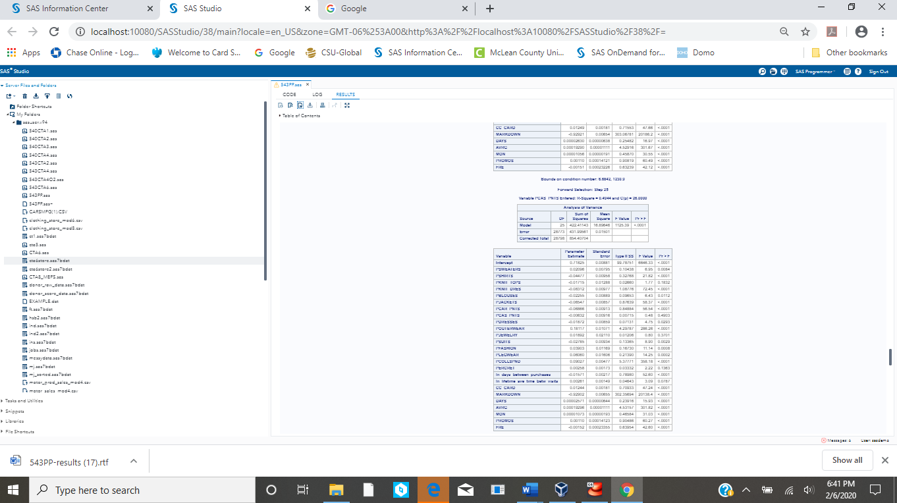

*Figure 9.* Regression Model of Profit

**Overall Analysis**

Insights gathered through this project lead to the need for exploring business questions not initially outlined for the project. The correlation and regression analysis for sales showed that frequency was a stronger contributor to sales than promotions. When evaluating the relationship between promotions and frequency, it appears that frequency increases with number of promotions received.

Analysis of the data by Customer Cluster, shows there are few large customer clusters (1, 10, and 4) and promotions are distributed more by the count of customer than by the customer cluster type. To further review Customer Cluster and adjust for cluster size, average sales and average promos were shown in a bar line chart in Figure 6. This view of the data shows that clusters 19,23,27.4,10, and 50 generate higher mean sales for the mean number of promotions.

To prepare final recommendations on promotion effectiveness, a deeper understanding of variables that influence promotions is needed. Figure 2 shows that DAYS (tenure as a customer) and CC_CARD also have moderate correlations to promotions. Analysis of variance using PROC ANOVA results show that both promotions and DAYS vary by credit card use (see Figure 10).



*Figure 10.* ANOVA of Credit Card with PROMOS and DAYS

In taking earlier analysis of promotions and ales by Customer Cluster and splitting by credit card use, the data visualization in Figure 11 on the right show the relationship of credit card use as similar across clusters in that mean promotions and mean sales are higher across all clusters for customers who use credit cards. Finally, the data visualization on the right of Figure 11 shows the mean tenure and mean frequency of visits by promotions received. This bar line chart shows that higher number promotions are sent to higher tenure customers which does not appear to be influenced by credit card use until about the 30 promotions level. Customers receiving 30-38 promotions appear to be credit card users. Regardless of credit card use, frequency of visits goes up with number of promotions.



*Figure 11.* Analysis of Means Split by Credit Card

**Summary and Recommendations**

According to (Epstein, Flores, Goodstein, and Milberg, 2016), promotions attempt to increase traffic, conversion rate, or sales. Frequency of visits is highly correlated to sales and is correlated to the number of promotions received. The retailer’s promotions are driving visits and sales. However, there is a significant variance in the number of promotions by tenure and use of credit card. The retailer will want to start with two promotion tests; one targeting lower tenure customers with more promotions and a second targeting non-credit card users with more promotions.

As for customer clusters to target, some clusters may generate higher mean sales for the number of promotions received (Clusters 19, 23, 27, 4,10, and 50). It is recommended the retailer start first with the low tenure and non-credit user promotions before testing promotion changes with the identified clusters. Lastly, the retainer should continue to monitor profit in relation to product sales as sales of Outerwear and Collectible impacted gross profit.

References

Buzzell, R., Gale, B., and Sultan, R. (1975) Market Share – a Key to Profitability. Harvard Business Review. Retrieved from: <https://hbr.org/1975/01/market-share-a-key-to-profitability>

Elliot, A and Woodward, W. (2016) *SAS Essentials Master SAS for Data Analytics, 2nd Edition*. New Jersey: Wiley and Sons.

Epstein, L., Flores, A., Goodstein, R., and Milberg, S. (2016) A new approach to measuring retail promotion effectiveness: A case of store traffic. Journal of Business Research 69, 4394-4402.

Appendix A

